Tree cost estimation for **Ahmednagar** District

Data:

1. I got the data of trees from the MNC of Ahmednagar district.
2. Searched the average co2 sequestration rate for each crop and calculated for all.
3. Source: <https://amc.gov.in/Tree%20Census%20Report%20AMC.pdf>

Data preprocessing:

1. Created a data frame in python.
2. Necessary transformations and calculations were performed, such as converting carbon sequestration rates into annual totals and calculating total planting costs.
3. The processed data was organized into a structured format in Excel.
4. The structured data was imported into Power BI for visualization.

Dashboard:

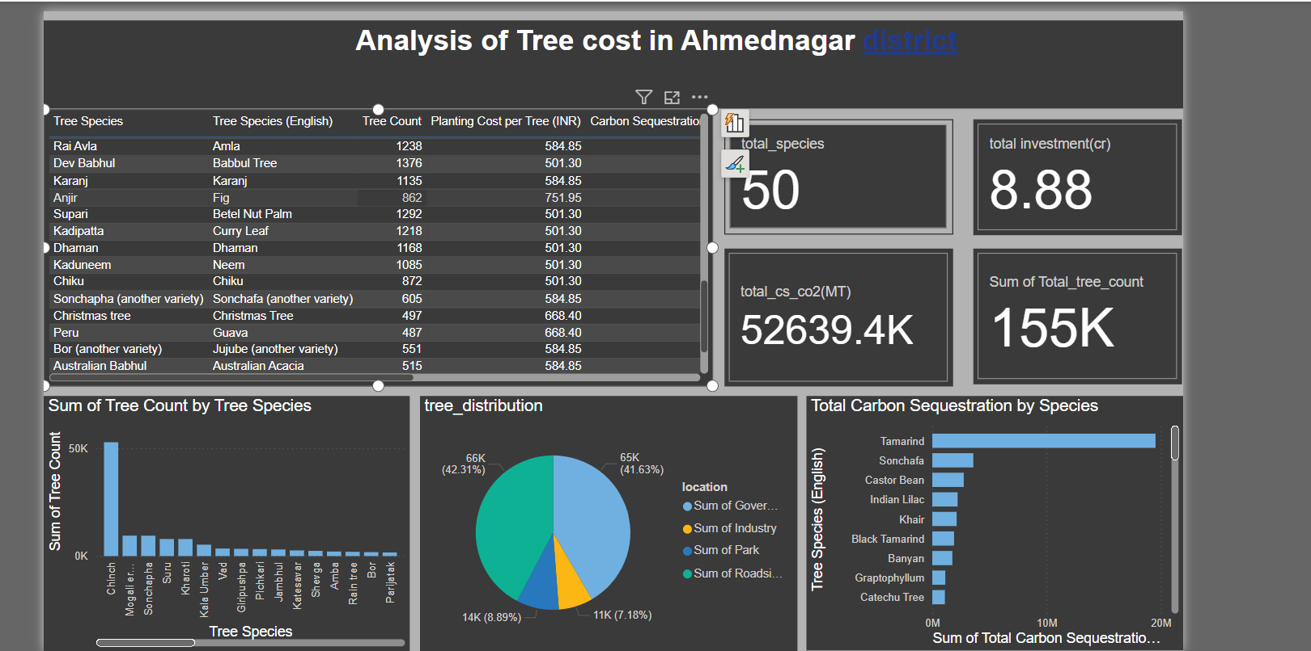

Report:

1. The total investment required for the project will be 8.88 Cr.
2. The total carbon sequestration rate is 52,639.4K MT.
3. The project includes 50 different tree species, with a total of 155,000 trees.